# Lab: Data Types and Variables

Problems for exercise and homework for the [Python Fundamentals Course @SoftUni](https://softuni.bg/trainings/3733/programming-fundamentals-with-python-may-2022).

Submit your solutions in the SoftUni judge system at <https://judge.softuni.org/Contests/1721>.

## Concat Names

Write a program that reads two names and a delimiter. It should print the names joined by the delimiter.

### Examples

|  |  |
| --- | --- |
| **Input** | **Output** |
| John  Smith  -> | John->Smith |
| Jan  White  <-> | Jan<->White |
| Linda  Terry  => | Linda=>Terry |

### Hints

* Read the data:

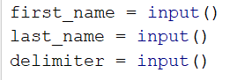

* Print:



## Convert Meters to Kilometers

You will be given an **integer** that represents a **distance** **in meters**. Write a program that **converts meters** to **kilometers** formatted to the second decimal point.

### Examples

|  |  |
| --- | --- |
| **Input** | **Output** |
| 1852 | 1.85 |
| 798 | 0.80 |

### Hints

* First, we read the input number:



* Then, we convert it to km:



* Finally, print the number formatted to the second decimal point:



## Pounds to Dollars

Write a program that **converts British pounds** (integer) **to US** dollars formatted to the 3rd decimal point.

1 British Pound = 1.31 Dollars.

### Examples

|  |  |
| --- | --- |
| **Input** | **Output** |
| 80 | 104.800 |
| 39 | 51.090 |

### Hints

* Read the pounds:



* Convert them to dollars:



* Finally, print the number formatted to the third decimal point:



## Centuries to Minutes

Write a program that reads an integer number of **centuries** and converts it to **years**, **days**, **hours**, and **minutes**.

### Examples

|  |  |
| --- | --- |
| **Input** | **Output** |
| 1 | 1 centuries = 100 years = 36524 days = 876576 hours = 52594560 minutes |
| 5 | 5 centuries = 500 years = 182621 days = 4382904 hours = 262974240 minutes |

### Hints

* Assume that one year has 365.2422 days on average ([the Tropical year](https://en.wikipedia.org/wiki/Tropical_year)).

## Special Numbers

Write a program that reads an integer n. Then, for all numbers in the range **[1, n]**, prints the number and if it is special or not (True / False). A number is **special** when the **sum of its digits is 5, 7, or 11**.

### Examples

|  |  |
| --- | --- |
| **Input** | **Output** |
| 15 | 1 -> False  2 -> False  3 -> False  4 -> False  5 -> True  6 -> False  7 -> True  8 -> False  9 -> False  10 -> False  11 -> False  12 -> False  13 -> False  14 -> True  15 -> False |
| 6 | 1 -> False  2 -> False  3 -> False  4 -> False  5 -> True  6 -> False |

### Hints

* First, we read the data:



* Iterate from 1 to n (we write n+1 because the for loop in Python iterates from 1 to n-1 by default):

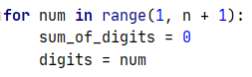

* To calculate the sum of digits of given number num, you might repeat the following: sum the last digit   
  (num % 10) and remove it (sum = sum / 10) until num reaches 0.

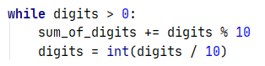

* Finally, print the result:

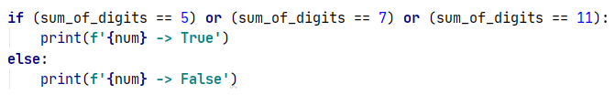

## Next Happy Year

You are saying goodbye to your best friend: "***See you next happy year"***. Happy Year is the year with only **distinct digits**, for example, 2018. Write a program that receives an integer number and finds the next happy year.

### Examples

|  |  |
| --- | --- |
| **Input** | **Output** |
| 8989 | 9012 |
| 1001 | 1023 |